Computer Language Coding Concepts

Command Calls in a Command Definition in a Diagram
This article demonstrates a situation of command objects.

This article illustrates how command calls in a command definition look in a diagram.

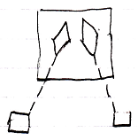

The large square is the parent command definition. The diamonds inside the parent command are two command calls. The diamonds are connected to squares with dashed lines. This makes those squares the command calls’ command definitions.

See also: Commands

Author & Copyright: Jan-Joost van Zon Date: August 9, 2008 – August 23, 2008 Location: Oosterhout, The Netherlands Status: Finished

